AKI ANIMAL WELFARE TRAINING REPORT

- Name of the organization
BAM ANIMAL CLINICS, Nakavule village , Iganga
ADDRESS: P. O BOX 55 IGANGA UGANDA
TELEPHONE +256 772487712
Email : balondemu_dav@bamanimalclinics.net
Website: https://bamanimalclinics.net

- Project title:
IMPROVING DONKEY WELFAREHEALTH THROUGH PRACTICAL TRAINING OF OWNERS HOW TO MAKE SADDLES FROM SISAL SACKS THAT WILL PROTECT DONKEYS FROM INJURIES.
3 Reporting period: From 22nd to 25th Sept 2021.
4. Objective and Background of the training.
To train donkey owners on how to make sisal sack saddles for donkeys to protect them from ill health due to wounds caused by poor/no harnessing in the Eastern region of Uganda covering the Districts of Kween , Bukwo and Kapchorwa .
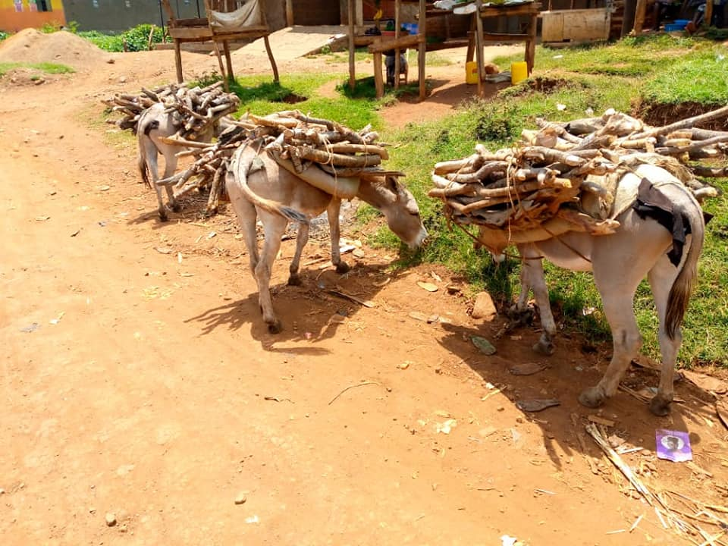
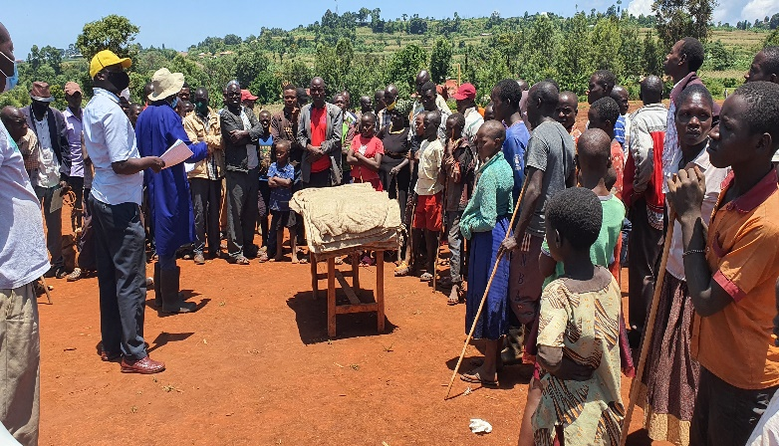

Donkeys are a major form of transportation of food, fire wood, harvests from gardens and water in the mentioned Districts especially considering that areas are less well serviced, with very limited good roads and bad terrains.
Veterinary services are considered too expensive to use here, most Donkey owners believe that Donkeys are never treated and this is attributed to lack of extension services to help educate Donkey owners the importance of treatment and care for Donkeys.
The region is covered with many hills and valleys with a poor road network that do not support the use of vehicles and relatively used by motorcycles but not for purposes of loading goods, quite often Donkeys are used instead to curry goods all the time.
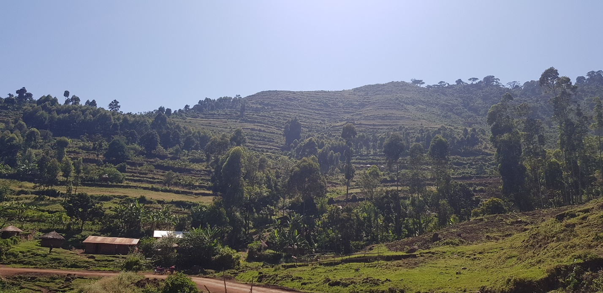

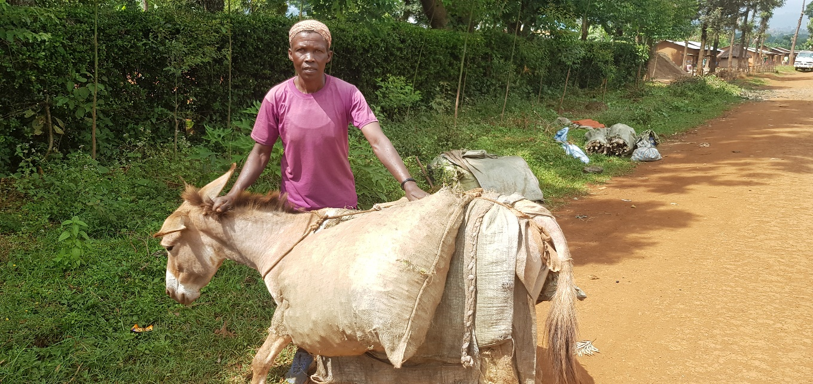
Women are the major users of these donkeys to transport food and firewood to local markets and other urban areas. Veterinary services are available mainly in the larger centers and the rural.

Government policy is to post a vet surgeon per sub-county assisted by at least 2 veterinary paraprofessionals. The irony is that most vets posted in these rural areas come back to partly or wholly work in towns or peri-urban for better pay and residency thus leaving most rural areas in dire need of expert vet services, quite often the paraprofessionals take-up the big role as they mostly stay in the rural. Most animals are in the rural areas which thus receive inadequate veterinary care and thus exposed to unnecessary pain and suffering.
Donkey welfare challenges exist arising from inadequate housing, poor feeding, worm infestations, poor harnessing causing skin lesions, trekking, overloading, Donkeys are tethered outside their owners’ homes to restrain their movement until they are needed again.
Donkeys have no shelters and quite often are left in the rain and sun, day in day out. During cropping seasons, donkeys are confined to prevent them from grazing in crops.
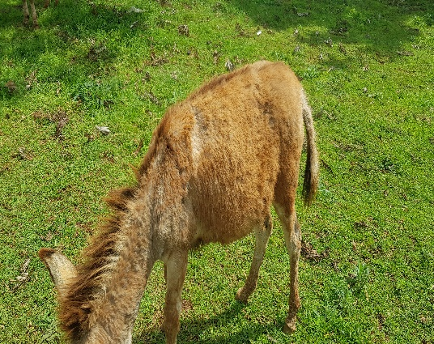
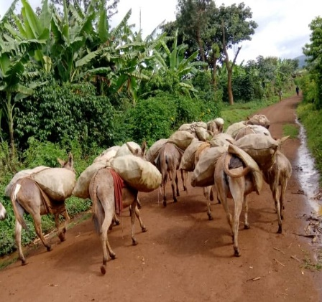
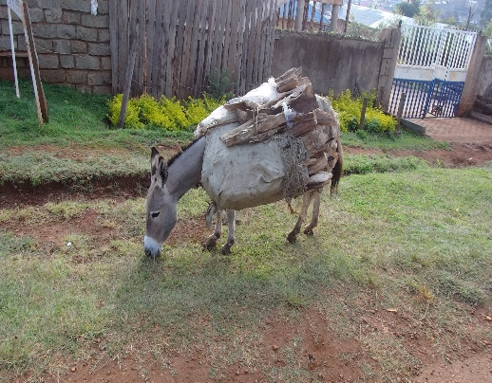
It is often the responsibility of children to tether donkeys at safer sites and this calls for a humane education program in schools.

Donkeys are slaughtered once they appear ill, or sold to butchers to meet financial obligations. Over loading transport Donkeys is a common practice.
Donkeys suffer the more especially during harvesting seasons as this is the time when communities are very active. The donkeys are used to curry produces from gardens to homes or to markets and sometimes wood from very far places to the market areas as well.
Activities:
Our work is to try and influence change towards humane handling, observance of the 5 freedoms, education on the use of appropriate Saddles, feeding and treatment.
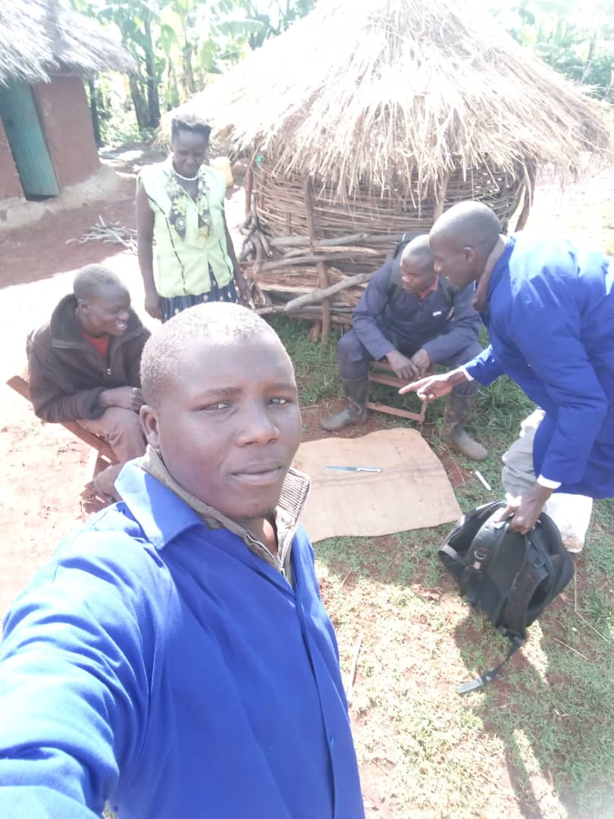
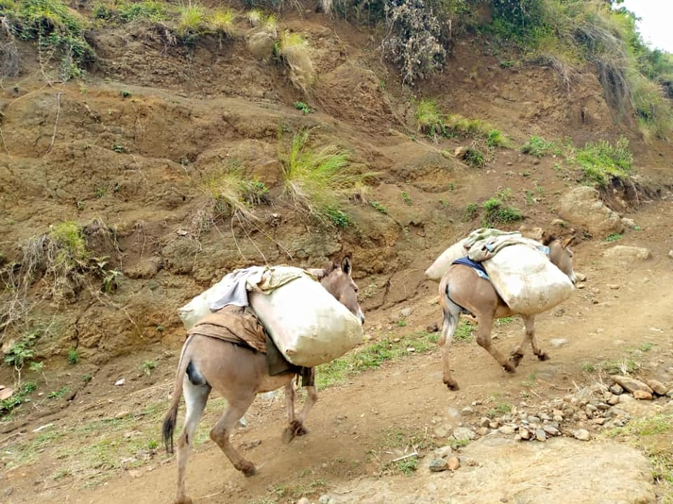
At the time when lockdown was instituted during the second wave, late May, our colleagues stationed continued doing the good work for the donkeys, the team would visit individual donkey owners in their communities, to offer advisory services and treatment to Donkeys with health issues.

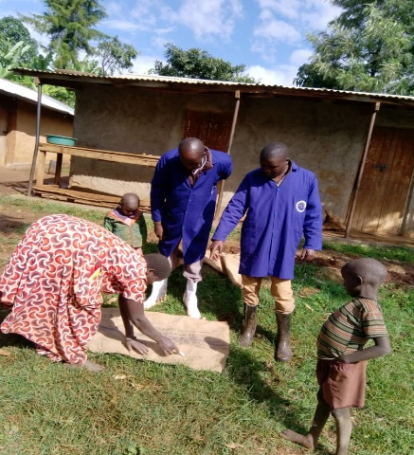
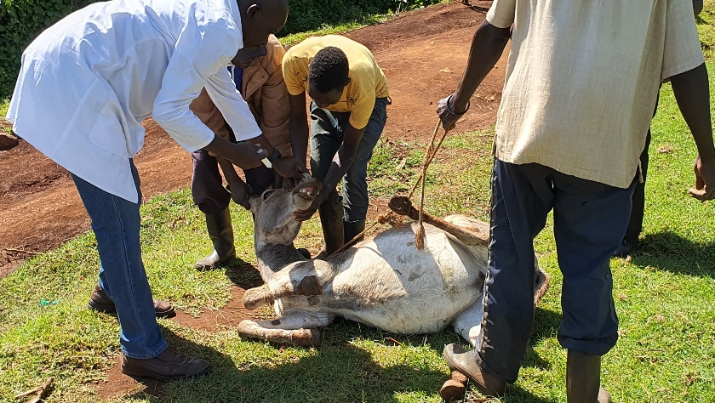

On the 22nd of September 2021, Our team loaded up with medicines and other supplies, headed east to Uganda's Elgon region in Kween District at the border with Bukwo District where the highest concentration of donkeys is found. On our way to the project places, we found poorly loaded Donkeys and what we did was to stop car and shared a word with the owners about the need to observe proper welfare practices. We advised the donkey owner on how there was hope to make his donkey carry the load with less pain.
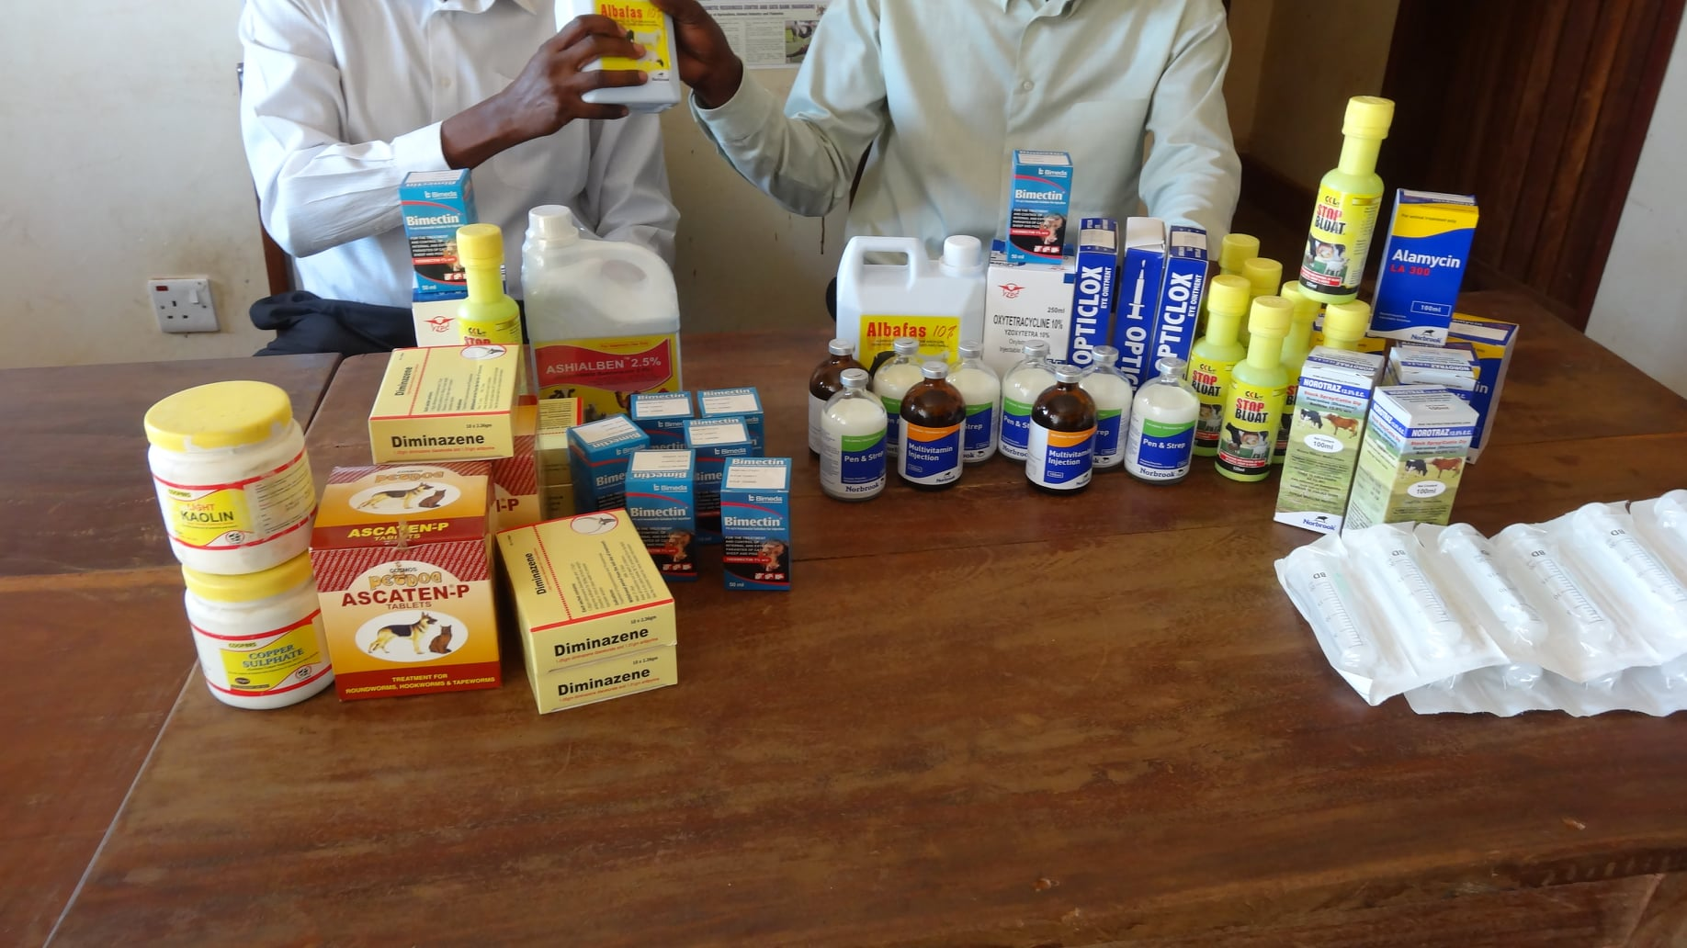

As always, our contact colleagues in Kween and Bukwo, comprising of Mr. Kwemoi Collins and Cheroto Jonah resp. would mobilize the communities to turn up for a donkey clinic at Kaproron Sub/county heard quarters.
The animal welfare concerns in the region are not only restricted to Donkeys, Dogs, Cats and definitely cattle are equally bleeding and need our equal support. Our trip coincided with the rabies week that climaxed on the 28th Rabies Day so throughout our engagements, we mobilized Dogs and Cats on site alongside the Donkeys for Rabies Vaccination and other managements free of charges.
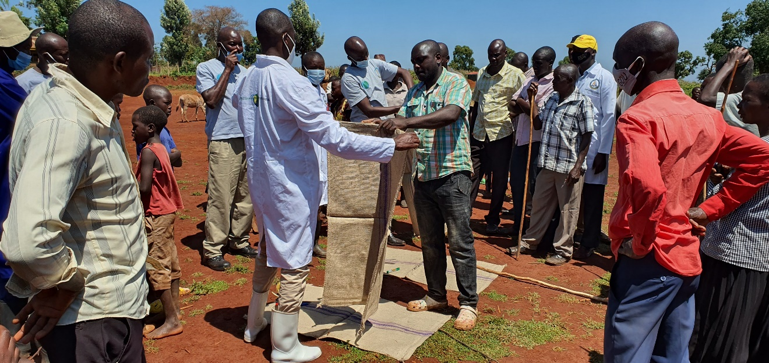
At Kaproron Sub/county headquarters, participants were mobilized to bring donkeys on site and were trained on how to make Sisal saddles. There was a lot of excitement and everyone was seen yearning to learn the new method of making saddles, we formed groups and each group was tasked to make their own Saddles and the team leader would take the sample.

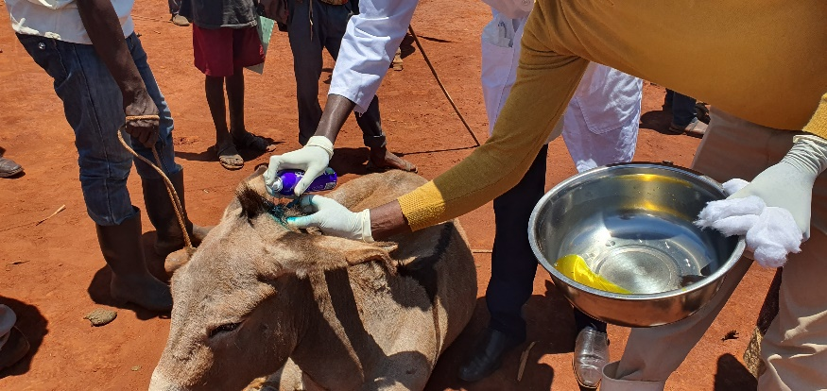
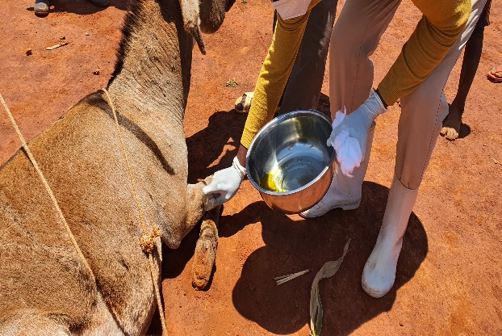
However, there were so many challenges as many donkeys had different types of health conditions and some others requiring simple surgeries. There was a donkey seen walking with a lot of difficulty (Limping) and on observation had a lacerated hoof with stones stuck in. The damage was severe so we preferred debridement. We managed the wound very well and had to make a follow up the following day. To my chagrin, this donkey could not be spared to continue carrying loads despite the state of her limb as told to me by one witness! We however advised the owner to keep her for quite a while before considered for any work lest she would lose the animal.

We believe that the skills acquired by the donkey owners will be used to improve on the conditions and health of their donkeys.
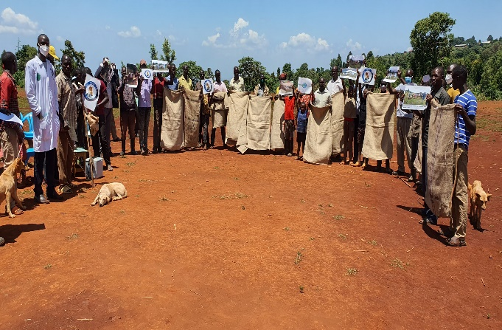
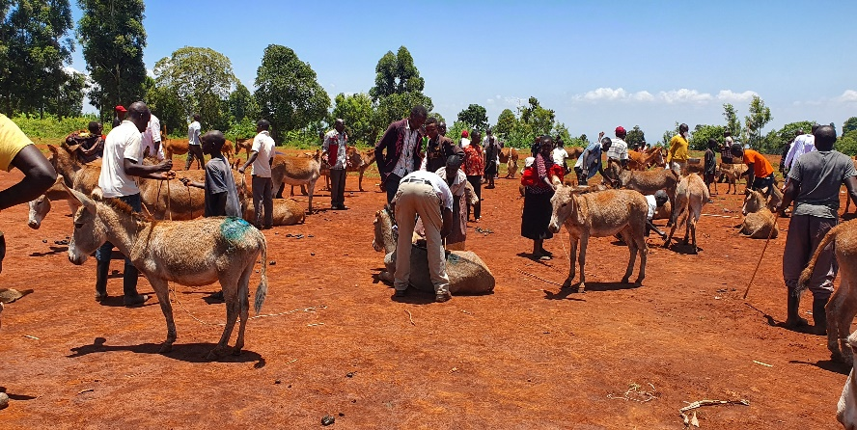

More than 100 pairs of sisal sacks were given out to communities as samples for making Sisal Saddles after our team had carried out demos. The project will help reduce pain and injuries on working donkeys especially who have continuously had issues of injuries due to overloading and poor harnesses.
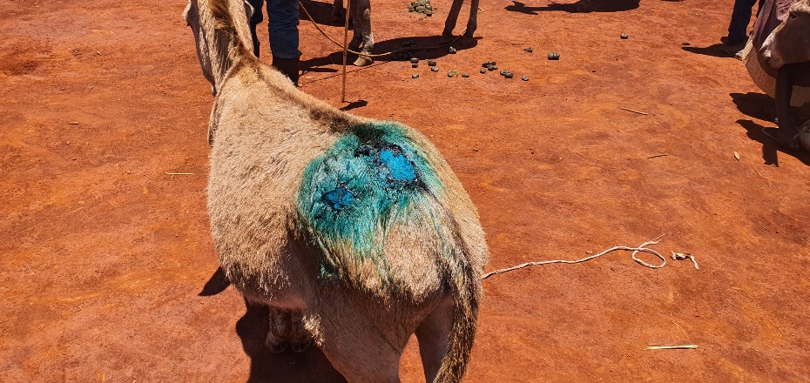
This young Donkey was presented for treatment on site with lots of wounds at the back, this time not due to loading but were told some Donkeys start training for transport reasons as early as this age, we were told sometimes the training is so intense that the victim is badly beaten and injured. We treated this Donkey and had a one on one talk with the owner to ensure he did not have to harm the donkey to have her work or learn to work.

Approximately 33,000 people die annually from rabies in Uganda mostly transmitted through dog bites. People are afraid of the infection here. Even innocent dogs and cats are short, beaten or poisoned because they are suspected to have rabies. But this approach brings no solution. The most effective way is through education Vaccination of dogs, castrated or sterilization, thus the number of stray animals is not increased any further. We have vaccinated during the past years in over 50 villages and towns more than 72,000 dogs.
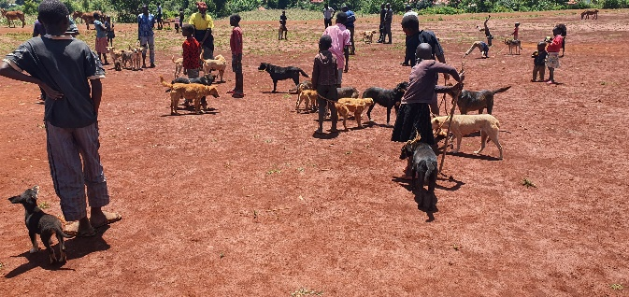
Celebrating the world rabies day 28th 09, we have had massive vaccination of dogs in Kween as part of our Donkey and Dogs welfare programs for a week. Certificates were given out for all dogs vaccinated, we also treated various health conditions presented.

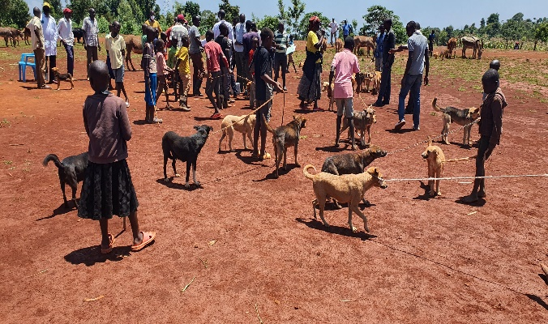

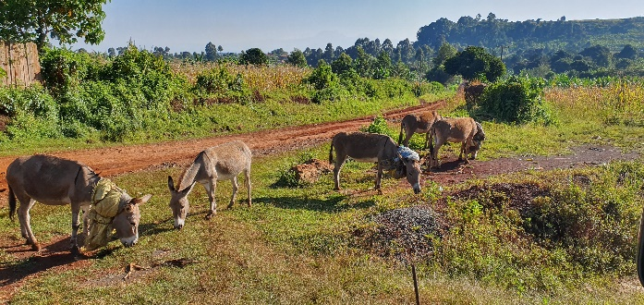

Milestone:
- Our team has been able to establish 20 trainers in 10 Sub/counties in the three Districts of Kween, Bukwo and Kapchorwa.
- The 20 trainers have since formed formed 4 groups each consisting of 5 ready to train members. We think the approach is the quickest way to spread the skills about Saddle making.
- The groups were successfully trained to make the sisal Saddles.
- Both the trainers and the community highly welcomed the program.
- Over 100 pairs of saddles are given out each visits at Sub/county levels.
- Over 200 families are using the saddles made from this project and their Donkeys are feeling a bit comfortable when used for transportation.
- We expect gradual attitude change from negativity to positive attitudes towards animals particularly donkeys.
6. Achievements
Bam animal clinics successfully launched an animal welfare program in Sebei region and hope to strengthen our grip in the whole region.
Bam animal clinics last year assumed partner’ status with Animal-kind International and this is a milestone to our quest to support the less privileged animals and people of the far East.
We have since 2020 supported many households with their Donkeys and have visited many sub counties in the three high Donkey concentrations of Kween, Bukwo and Kapchorwa
The level of response towards the new innovation has been high from day one resulting into quick adoption of making Saddles.
Animal owners in this region can now test a more holistic approach to the welfare of their animals through Bam animal clinics supported by Animal Kind International.
Issues: -
Need for more logistical support to acquire enough medications, fuel staff upkeep.
Poor road network requires that two more moto bikes for field staff be procured.
Bam hires a 4-wheel drive to reach further than it would be for small cars , this is essential and given more funds, the remotest areas in Bukwo and Kween will by all means benefit from the much needed AKI program.
Rainy seasons make our travel to the project areas not quite possible as a result of very dangerous / Slippery roads.
Lessons learned;-
Donkeys suffer grossly as they trek long distances to ferry goods to markets.
The poor and very expensive transport means with bad road networks in the region is by no means that force locals to resort to using animals for transport.
We realized animals go for long without getting any medication and the use of even limping donkeys to carry goods to the market.
Foot note:
Bam animal clinics highly thanks our partners the Animal Kind International for their consideration to support our project.
We reiterate our commitment to continue working together to ensure full transformation of the donkey welfare in the region.
Prepared by:
DAVID BALONDEMU
Director/ Bam animal clinics.
